Wilson Tennis Racket
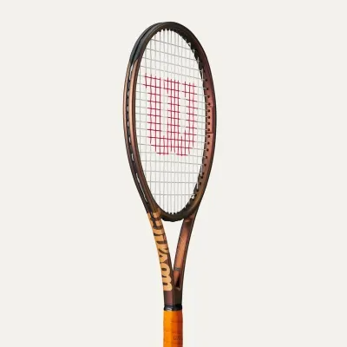
PRICE: Approximately Rs. 15,999

_{Introduction:}
The Wilson Tennis Racket is a high-performance sports essential designed for players who want power, control, and comfort on the court. Trusted by professionals and beginners alike, Wilson rackets deliver consistent performance with advanced technology.

This Photo by Unknown Author is licensed under CC BY
Product Overview:
This Wilson Tennis Racket is engineered to enhance shot accuracy, swing speed, and overall gameplay. Its balanced frame and responsive string bed make it suitable for both practice sessions and competitive matches.
About the Brand:
Wilson is a globally renowned sports brand with decades of excellence in tennis equipment. Used by world-class players, Wilson is known for innovation, quality craftsmanship, and professional-grade performance.

Key Features:
- Excellent balance between power and control
- Lightweight frame for easy handling
- Shock-absorbing technology for arm comfort
- Suitable for multiple playing styles
- Professional-quality string pattern

Design & Build Quality:
The racket features a sleek, modern design with a sturdy yet lightweight frame. Its ergonomic grip ensures a firm hold, while the aerodynamic structure supports faster swings and improved control.

Storage & Capacity:
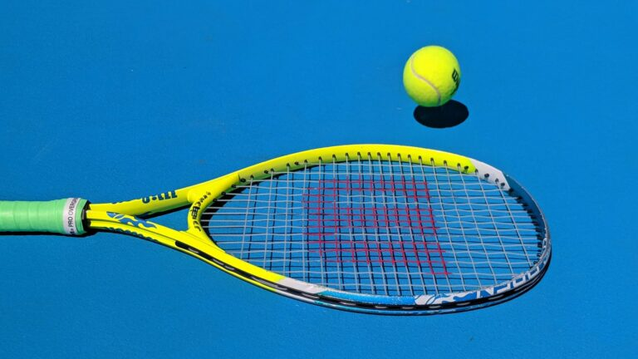
Designed as a single-racket sports item, it fits easily into standard tennis racket covers and sports bags without taking extra space.
This Photo by Unknown Author is licensed under CC BY-ND

Material & Durability:
Made from high-quality graphite and composite materials, the Wilson Tennis Racket offers long-lasting durability, flexibility, and resistance to wear during intense gameplay.

Ideal For:
- Beginner to intermediate players
- Tennis learners and academy students
- Recreational and competitive players
- Adults and teenagers

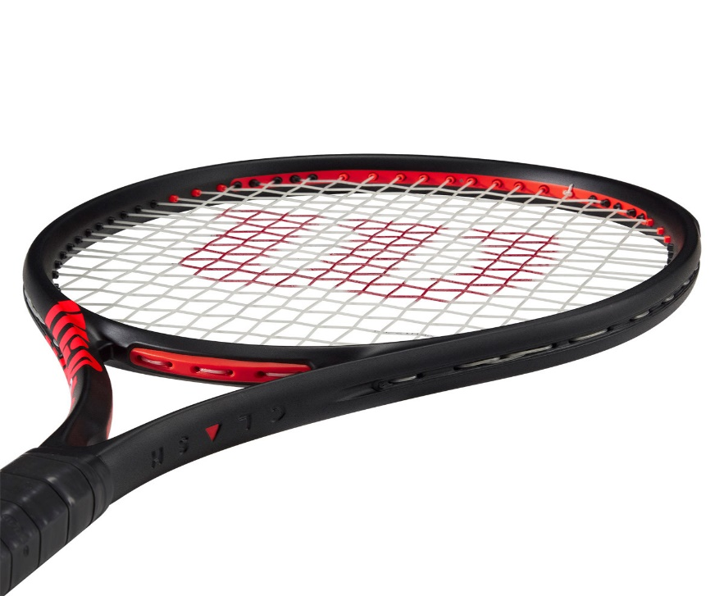

Care Instructions:
- Store in a protective racket cover when not in use
- Avoid extreme heat and moisture
- Clean grip regularly to maintain hygiene
- Do not hit hard surfaces with the racket
Product Specifications:
- Brand: Wilson
- Product Type: Tennis Racket
- Frame Material: Graphite/composite
- Grip type: cushioned ergonomic grip
- Weight: Light weight
- Usage: Training & Match Play

Product Summary:
The Wilson Tennis Racket is a reliable, durable, and performance-driven choice for players looking to improve their game. With trusted brand quality and player-friendly design, it is an excellent investment for tennis enthusiasts at any level

